16.15: a) See Exercise 16.14. The amplitude is
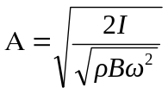

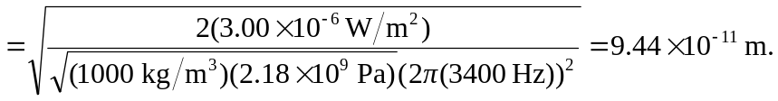

The wavelength is

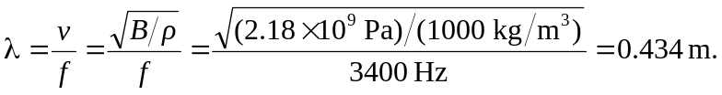

b) Repeating the above with 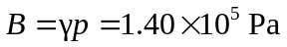 and the density of air gives 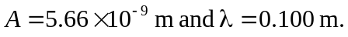 c) The amplitude is larger in air, by a factor of about 60. For a given frequency, the much less dense air molecules must have a larger amplitude to transfer the same amount of energy.

